Lab Exercise 7– Terraform Variables with Command Line Arguments

Name- Garvit janu
SAP ID- 500119646
Batch-3 (DevOps)
Objective:
Learn how to pass values to Terraform variables using command line arguments.
Steps:
- Create a Terraform Directory:
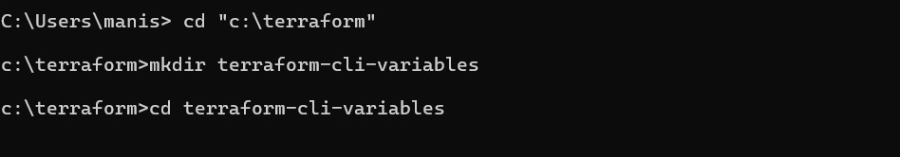
mkdir terraform
-
cli
-
variables

cd terraform
-
cli
-
variables

- Create Terraform Configuration Files:
  - Create a file named main.tf:
# instance.tf
resource "aws_instance" "example" {
ami = var.ami
instance_type = var.instance_type
}
  - Create a file named variables.tf:

# variables.tf
variable "ami" { description = "AMI ID" default = " ami-08718895af4dfa033"
}

variable "instance_type" { description = "EC2 Instance Type" default = "t2.micro"
}
- Use Command Line Arguments:
  - Open a terminal and navigate to your Terraform project directory.
  - Run the terraform init command:
terraform init
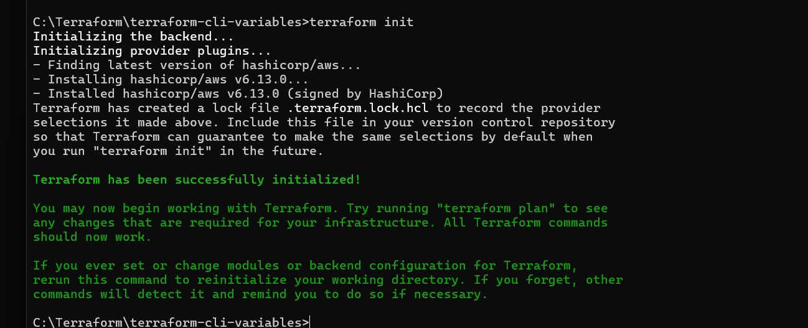

  - Run the terraform apply command with command line arguments to set variable values:
terraform plan -var=”ami=ami-0522ab6e1ddcc7055” -var=”instance_type=t3.micro”
  - Adjust the values based on your preferences.

- Test and Verify:
  - Observe how the command line arguments dynamically set the variable values during the apply process.
  - Access the AWS Management Console or use the AWS CLI to verify the creation of resources in the specified region.
- Clean Up:
After testing, you can clean up resources:
terraform destroy
Confirm the destruction by typing yes.

